**Department of Electrical and Computer Engineering**

**North South University**



**Senior Design Project**

**Project Proposal**

**Title of Project**

**Name 1 ID #**

**Name 2 ID #**

**Name 3 ID #**

**Faculty Advisor:**

**Syed Athar Bin Amir**

**Lecturer**

**ECE Department**

**Summer, 2020**

Contents

1. Abstract 2

1.1 Introduction 2

1.2 Objectives 2

1.3 Roles 2

1.4 Teachers 2

1.5 Istitutions 2

1.6DevelopmentTechnology……………..………………………………………………………2

1.7 Time line 2

1.8 Project goal 2

**Group project proposal**

Proposal of Learning Management System Implementation

**1.Abstract**

Learning management systems (LMS) can be defined as a suite of services designed to

deliver, track, report on and administer learning content, student progress and student interactions typically, an LMS provides an instructor with a way to create and deliver content, monitor student participation, and assess student performance. It integrates a range of functions for teaching and learning activities. LMS makes the interaction between learner-instructor and learner-learner more convenient. It provides a platform on the web, and a lot of pedagogical activities can be performed on it .Nowadays most educational institutions adopt LMS via the used of open sources such as Bux, Google classroom,, MEET, Zoom ets learning and assessment activities in a specific learning environment . LMS provides a variety of tools such as a blog, chat, my courses, class time, class work, my profile, attendance, notification, advising, resources etc. Faculties can also use these kind of facilities .Learners can use these features to facilitate their communication and collaborative work in this learning environment.

## 1.1 Introduction

Learning management systems (LMS) can be defined as a suite of services designed to deliver,

## track, report on and administer learning content, student progress and student interactions. The varsity admin can control the system. The importance of these systems is growing as far as terms such as internet-based educational system, educational service Provider, and Distance learning or On-demand education are becoming popular.**On this modern era and pandemic situation there is necessity of online learning platform based on Bangladesh curriculum. Most of the educational institution doesn’t have any online learning management system. Some of them owned a system but which are not fully function and effective for both students and faculty members. On this pandemic situation numerous students regular educational work flow is getting hampered and lack of a systemic management system, institutions are unable to track/follow their protocol and facing difficulty manage their large number of students.** **Under this circumstance, there is a necessity to build such a kind of advance learning management system which will be universal for all institution, connect everything on one place and full fill their basic core.**

## 1.2 Objectives

The main goal of an LMS is to manage the learning process and connect everything in one place. It will be such a system that works in an automated, pre-determined way. It allows Institution to get registered and create their necessary filed and roles. A platform where student faculty can create a good interaction and assets are uploaded to the Learning Management System, which makes them easily accessible for remote learners. Faculty will able to take class with video conference and able to grade their students based on the assigned task. Student can also take part on group studies over the platform which will also help to enhance their learning. For open credit University the system will create a advance advising system which allows to student to take their desire course with time and also this will be available for faculty to take their desire course with time.

The Owner of this LMS platform will offer such subscription base packages for institution to get registered and flow their curriculum. Which helps the owner to enhance their functionality smoothly.

## 1.3 Roles

**I) Faculty/Teacher.**

**II) Institution.**

**III) Student.**

**IV) Owner.**

## The Opportunities and functional facilities for every Roles

## 1.4 Faculty/Teacher

I. My courses: In this function instructor can see which courses and sections

he is taking in a particular semester.

II. Class time: Here instructor can watch his class timing with weekly days.

II. Manual attendance: This function will allow to take attendance manually and

see the total present and absent student number.  
III. Notification: Here the system will show all kind of notification for the instructor.  
IV. Sent notification: From here instructor can send any kind of notification to the   
students.  
V. Upload grade: This function will give instructor upload grade features for all the   
students in his particular course section.  
VI. Assign work: Here instructor can assign any kind of cw or hw for the students.

VII. Upload file: Here instructor can upload any kind of reading materials.  
VIII. View assignment: In this function instructor can view the submission, late   
submission or missing assignment with name and id of any students.  
IX. My profile: This function will show details of any particular instructor.

X. Offer course time: This feature will allow the instructor to set his preferable time for   
the course to the institution.   
XI. Dashboard: It will show particular days classes, recent class work, recent notifications

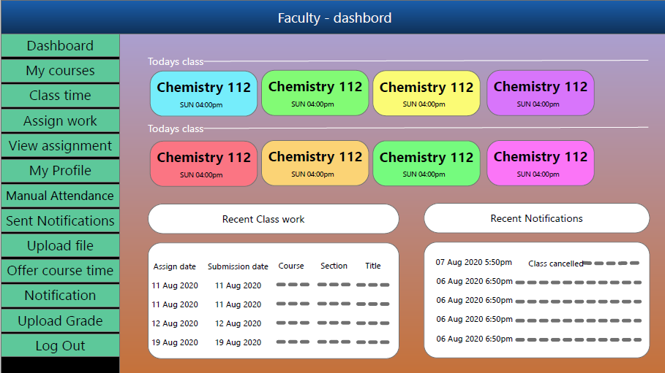

## 1.5 Institution

I. courses: In this function institution will assign courses to the instructor, students and can

Can manage all courses and theirs section and time also.

II. Faculty: Here institution can add faculty, delete faculty, modify faculty information.

III. Student: Here institution can add student, delete student, modify student information.  
IV. Sent notification: From here institution can notify all students and instructor or any

particular student or instructor.  
V. Grade: This function will provide the grade of all student and Institution can watch any

particular students grade also.

VI. Assign courses: Here institution can assign any course to the student and instructors.

VII. Advising rules: Here institution can set the rules of course registration.  
VIII. Result backup: Here institution will have backup for all results of every students.  
IX. University profile: This function will show details of that institution which registered

into the system.

X. Add role: Here institution can assign the role for any instructor.

XI. See offer course time: Here institution can see the desired courses and their time of

Any student’s or instructor’s.  
XII. Dashboard: It will show all students, courses and instructor under the institution.

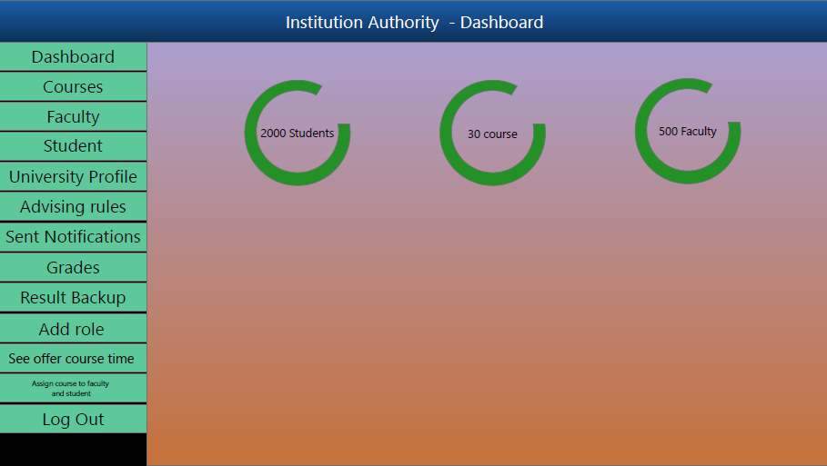

## 1.6 Development Technology

* HTML, CSS, Bootstrap
* Laravel, JavaScript, Ajax, Jquery
* MySQL

## 1.7 Timeline

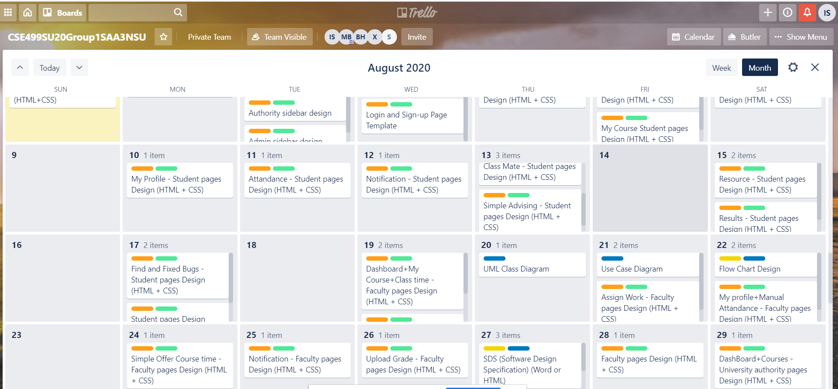

## Full timeline link : <https://trello.com/invite/b/AX0naDJb/c79014bfdbf759eaca7358010d24b405/cse499su20group1saa3nsu>

## 1.8 Project Goal

The goal of this project is to help the institution to manage students and teacher with a single system. Make the work for the teachers and students easy. It is clearly seen that sources of information in internet are increasing rapidly and make life-long learning easy as parallel to improvements occurred in information technologies Every secured information on internet can be reached quickly and easily but most of information sources on internet are not suitable to standards. The processes of searching, choosing and reusing come into prominence while the information sources are increasing rapidly. It will make everything easy for institutions, teachers and students with various features.

## References:

[1] <https://www.trustradius.com/student-management-systems>

[2] <https://www.youtube.com/watch?v=qP68aVNg6RE>

[3] <https://www.sourcecodester.com/php/12060/student-management-system-using-php-and-mysql.html>

[4] <https://www.ittrainingnepal.com/php-project/student-management-system/>